1. For each of the following measuring devices (a) Record the measurement (b) indicate the number of significant figures in the measurement (3) identify the uncertainty in the measurement
Measuring device | Measurement | Significant Figures | Uncertainty
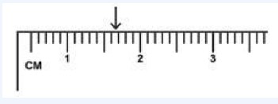
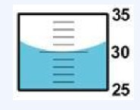
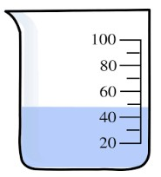
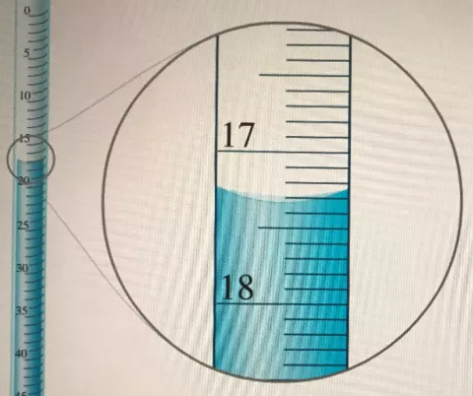
 |  |  | /12

2. Identify the number of significant figures in each of the following measurements.
(a) 301.200 g | (b) 0.01302 g | (c) 30000 g | (d) 80.00300 g
 |  |  |  | /4

3. Round the following to the appropriate significant figures
(a) 34.06 to the ones. | (b) 9.1999 to the hundredths | (c) 1.998 to the hundredths | (d) 48.9909 to the tens
 |  |  |  | /4

